
Touchstones
Netcards

Reason Netcards with Text

Argue HRJ
Curiosity HRJ
Devastation HRJ
Drama Masks HRJ

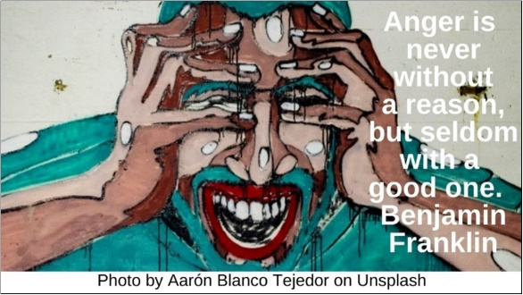

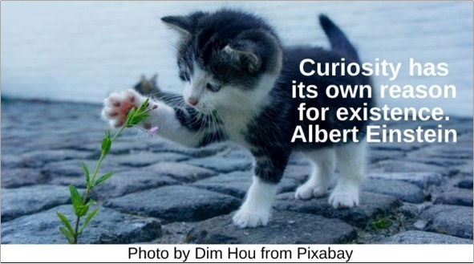

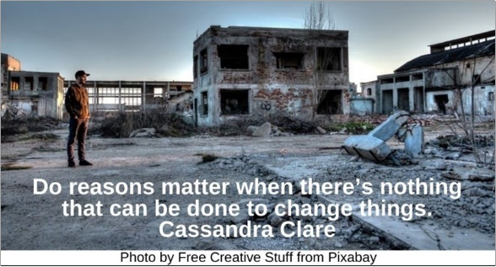

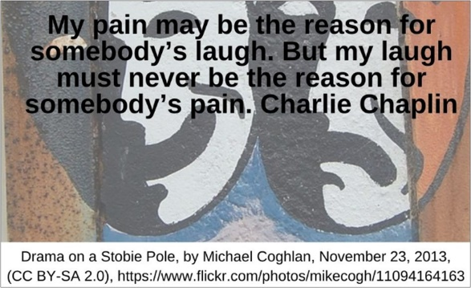

Emotion and Reason HRJ
Fence HRJ
Fork in the Path HRJ
Galileo HRJ

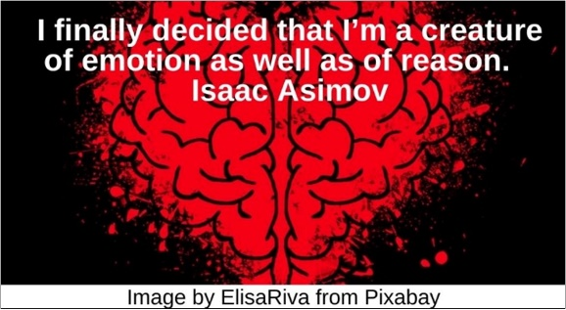

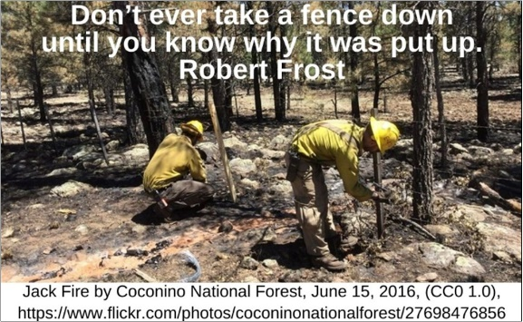

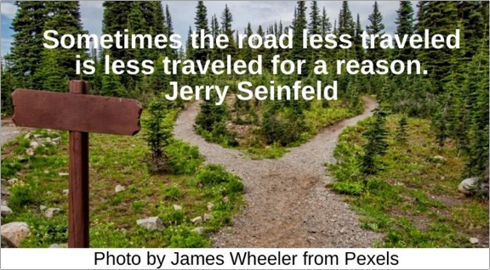

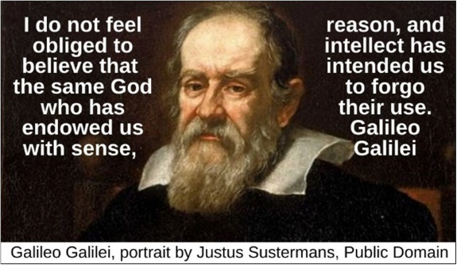

Giraffe HRJ
Groucho Marx HRJ
Heart HRJ
Hour Glass HRJ



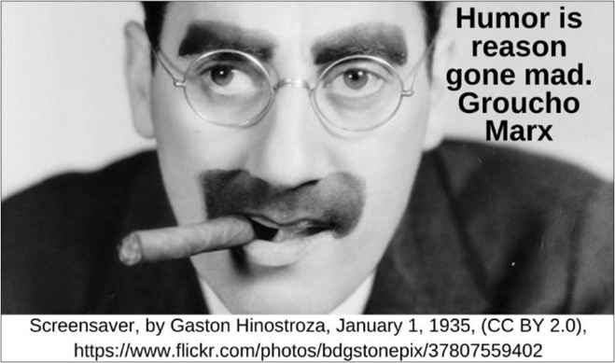

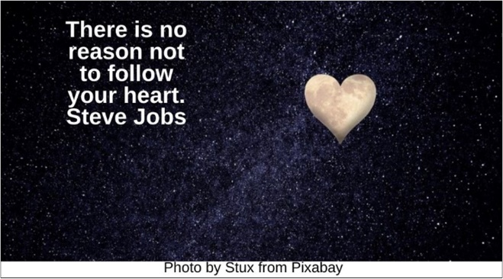

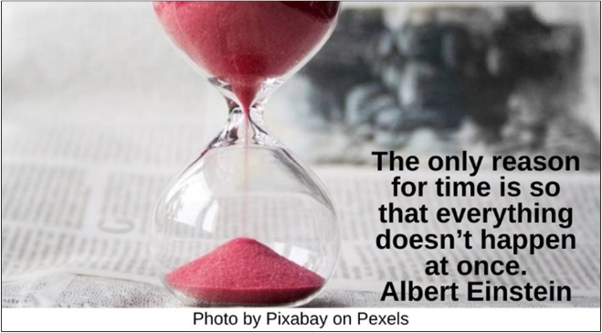

Ice Cream HRJ
Imagination HRJ
Inquisition HRJ
James Baldwin HRJ

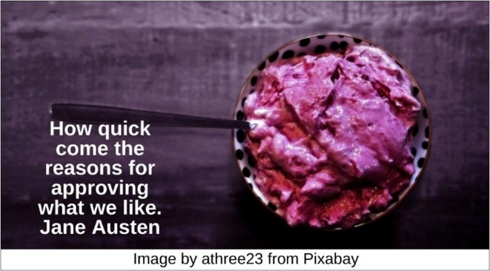

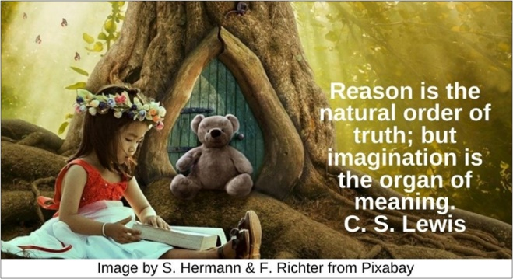

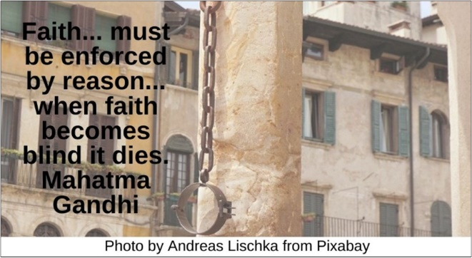

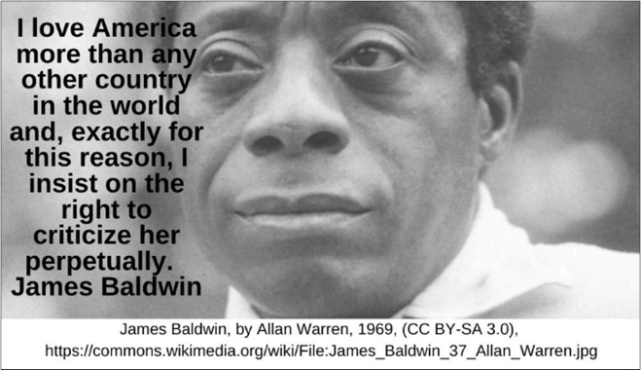

Leo Tolstoy HRJ
Lost HRJ
Martial Arts HRJ
Old Locomotive HRJ

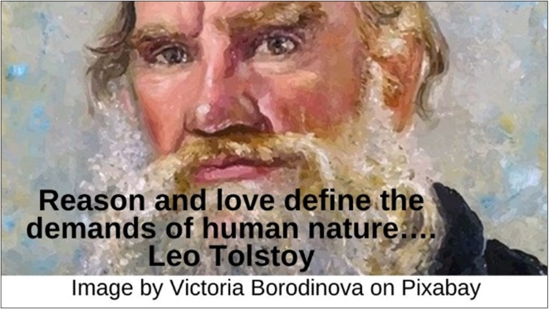

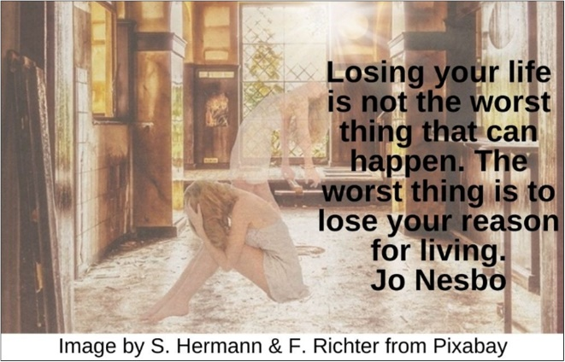

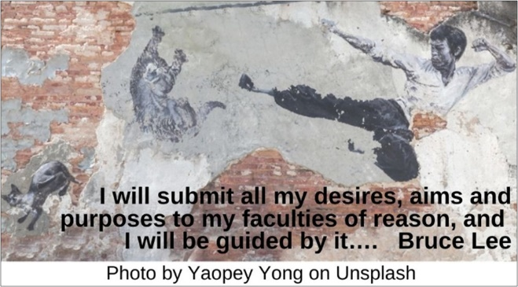

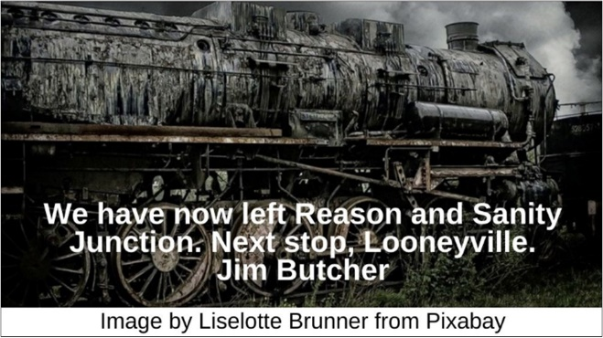

Poetry HRJ
Politics HRJ
Reason HRJ
Riding a Horse HRJ

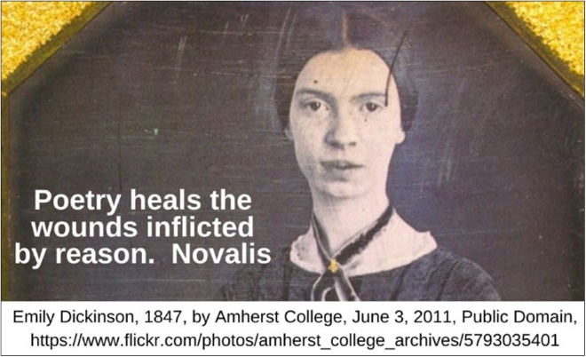

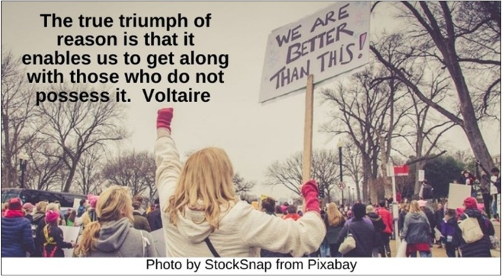

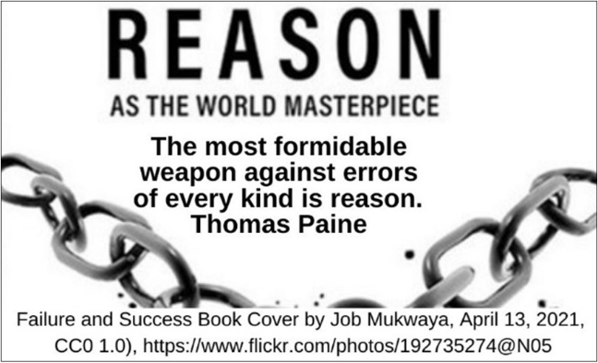

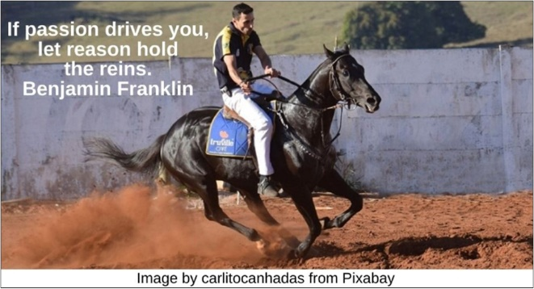

Speaking HRJ
Sunset HRJ
Surfing HRJ
Tree HRJ

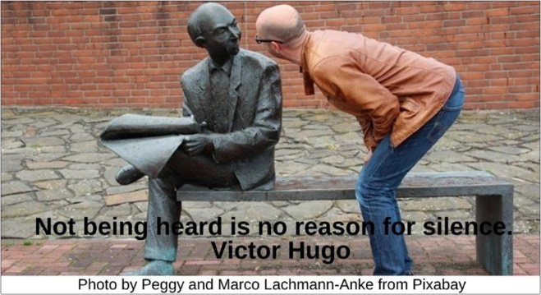

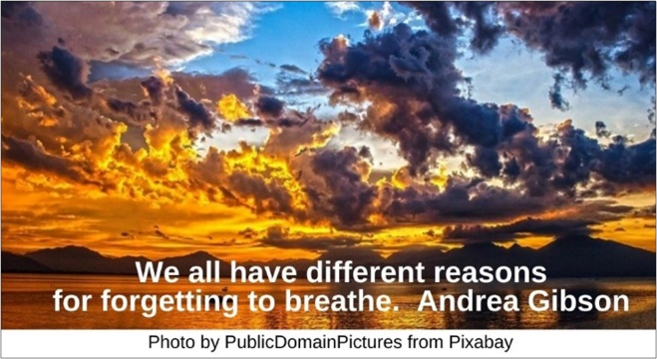

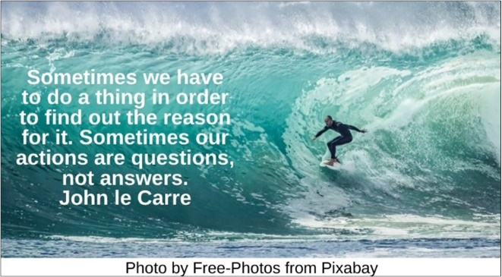

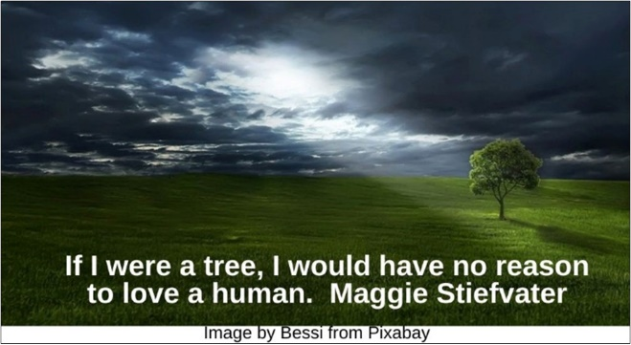

White Supremacy HRJ
Work HRJ
Yin Yang HRJ

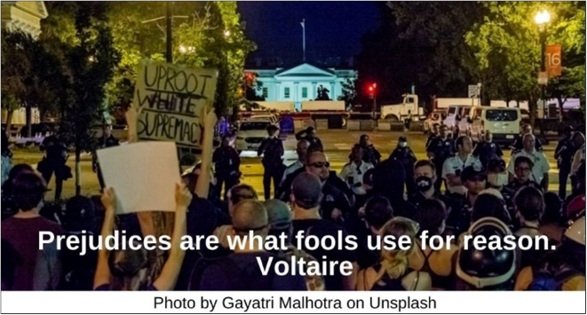

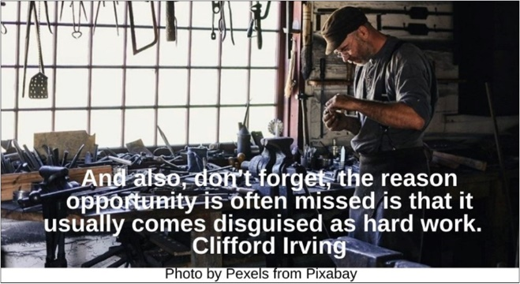

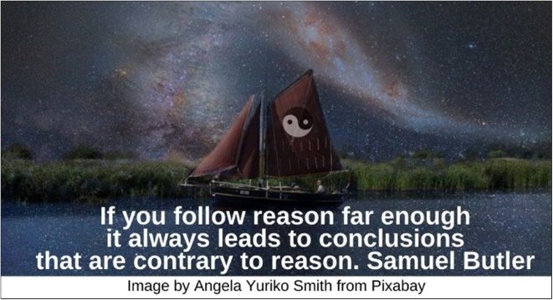

Text of Quotes
Anger HRJ
Anger is never without a reason, but seldom with a good one. Benjamin Franklin

Curiosity HRJ
Curiosity has its own reason for existence. Albert Einstein

Devastation HRJ
Do reasons matter when there’s nothing that can be done to change things. Cassandra Clare

Drama Masks HRJ
“My pain may be the reason for somebody’s laugh. But my laugh must never be the reason for somebody’s pain.” Charlie Chaplin

Emotion and Reason HRJ
I finally decided that I’m a creature of emotion as well as of reason. Isaac Asimov

Fence HRJ
Don’t ever take a fence down until you know why it was put up. Robert Frost

Fork in the Path HRJ
Sometimes the road less traveled is less traveled for a reason. Jerry Seinfeld

Galileo HRJ
I do not feel obliged to believe that the same God who has endowed us with sense, reason, and intellect has intended us to forgo their use. Galileo Galilei

Giraffe HRJ
The animals of the world …were not made for humans any more than black people were made for white, or women created for men. Alice Walker

Groucho Marx HRJ
Humor is reason gone mad. Groucho Marx
Heart HRJ
There is no reason not to follow your heart. Steve Jobs

Hour Glass HRJ
The only reason for time is so that everything doesn’t happen at once. Albert Einstein

Ice Cream HRJ
How quick come the reasons for approving what we like. Jane Austen

Imagination HRJ
Reason is the natural order of truth; but imagination is the organ of meaning. C. S. Lewis

Inquisition HRJ
Faith... must be enforced by reason... when faith becomes blind it dies. Mahatma Gandhi

James Baldwin HRJ
I love America more than any other country in the world and, exactly for this reason, I insist on the right to criticize her perpetually. James Baldwin

Leo Tolstoy HRJ
Reason and love define the demands of human nature…. Leo Tolstoy
Image by Victoria Borodinova on Pixabay

Lost HRJ
Losing your life is not the worst thing that can happen. The worst thing is to lose your reason for living. Jo Nesbo

Martial Arts HRJ
I will submit all my desires, aims and purposes to my faculties of reason, and I will be guided by it…. Bruce Lee

Old Locomotive HRJ
We have now left Reason and Sanity Junction. Next stop, Looneyville. Jim Butcher

Poetry HRJ
Poetry heals the wounds inflicted by reason. Novalis

Politics HRJ
The true triumph of reason is that it enables us to get along with those who do not possess it. Voltaire

Reason HRJ
The most formidable weapon against errors of every kind is reason. Thomas Paine

Riding a Horse HRJ
If passion drives you, let reason hold the reins. Benjamin Franklin

Speaking HRJ
Not being heard is no reason for silence. Victor Hugo

Sunset HRJ
We all have different reasons for forgetting to breathe. Andrea Gibson

Surfing HRJ
Sometimes we have to do a thing in order to find out the reason for it. Sometimes our actions are questions, not answers. John le Carre

Tree HRJ
If I were a tree, I would have no reason to love a human. Maggie Stiefvater

White Supremacy HRJ
Prejudices are what fools use for reason. Voltaire

Work HRJ
And also, don’t forget, the reason opportunity is often missed is that it usually comes disguised as hard work. Clifford Irving

Yin Yang HRJ
If you follow reason far enough it always leads to conclusions that are contrary to reason. Samuel Butler

